services Ulladulla 9am and 4pm / Milton 11am  prayer meeting Milton 2.30pm Thursday  web ulladulla – anglican.org  office Ulladulla site (Princes Hwy x Green St)  phone (02) 4454 2030  email office@ulladulla-milton-anglican.org  senior pastor Aiden Sibrava  phone 0437 903 986  email aiden@ulladulla-milton-anglican.org  rest day Wednesday  assistant pastor Steve Klouth  phone 0423 395 429  email steve@ulladulla-milton-anglican.org  rest day Thursday  bookshop (02) 4454 2030  bookstore@ulladulla-milton-anglican.org  open Mon – Fri 10am – 4pm  safe ministry Peter Kerma / 0450 960 908  parish council see website  __________________________________________________________  support our mission  Ulladulla BSB 032 701 ACN 245 648  Milton BSB 633 108 ACN 157 807 868 |  | South Coast Anglican Churches  Milton & Ulladulla  Here for Jesus  Here for the Coast    Thank you for joining us today and a special welcome if you are visiting  13 April 2025  “We Belong to the Day”  Steve Klouth  Luke 19: 28 - 44 1Thessalonians 5:1 - 11  Parish Councillor on duty  9am: Nathan Ross  11am: Lea Kendall  4pm: Bart Vanden Hengel
1 Thessalonians 5:1 - 11  5 Now, brothers and sisters, about times and dates we do not need to write to you, ² for you know very well that the day of the Lord will come like a thief in the night. ³ While people are saying, “Peace and safety,” destruction will come on them suddenly, as labour pains on a pregnant woman, and they will not escape. ⁴ But you, brothers and sisters, are not in darkness so that this day should surprise you like a thief. ⁵ You are all children of the light and children of the day. We do not belong to the night or to the darkness. ⁶ So then, let us not be like others, who are asleep, but let us be awake and sober. ⁷ For those who sleep, sleep at night, and those who get drunk, get drunk at night. ⁸ But since we belong to the day, let us be sober, putting on faith and love as a breastplate, and the hope of salvation as a helmet. ⁹ For God did not appoint us to suffer wrath but to receive salvation through our Lord Jesus Christ. ¹⁰ He died for us so that, whether we are awake or asleep, we may live together with him. ¹¹ Therefore encourage one another and build each other up, just as in fact you are doing.  Notes |  | Special prayers this week  * For all those in our church family who are sick, injured, mourning  a loss or recovering from treatment  * For our hospital chaplains, Colleen Clifford and Rod Foord –  that God would open doors and open hearts to the words of  comfort from Scripture that they offer  * For Bernie and Michelle Hughes and their family.  * For Milton Ulladulla Baptist Church as they continue their  search for a new minister and for Steve Mann as he leads the  church in the interim.  * For the amazing work being done each week at Burrill Pines  * For Miriam Bradshaw and her mission work in Spain  * For financial support for the ‘Safe Waters’.  * For financial support for the UCEF ministry in Ulladulla High  * For those suffering from the floods in central Australia and  those working to help support those experiencing isolation  and loss  Our Mission prayer  Lord, as we hear Jesus' words, cause us to be a people united in  faith, and committed to serving each other. Help us especially  to be devoted to the mission you have given us: proclaiming the  Gospel on the South Coast. May we shine as a light for Jesus in  what we say and in what we do. Amen
Open Door  Open Door will not meet again until Tuesday 29th April. The Open Door ladies look forward to seeing everyone there at 10am on Tuesday 29th April to share in morning tea and games, craft and fellowship. |  |   EASTER IS A TIME OF CELEBRATION  Why not contribute some flowers or greenery? Or even some time! Milton Church needs your contributions to make Easter a special time. Can you give an hour on Easter Saturday to help with floral arrangements? To offer flowers or time please contact Viv Davidson on 0405 409 119
Join the Faithful 5 Initiative!  Inspired by a generous parishioner who gave $5,000 last year to support our church, we’re launching the Faithful 5 offertory initiative to cover our 2025 budget deficit of $97,539. We’re asking 100 people to step up with a  special gift—at a level that works for you:  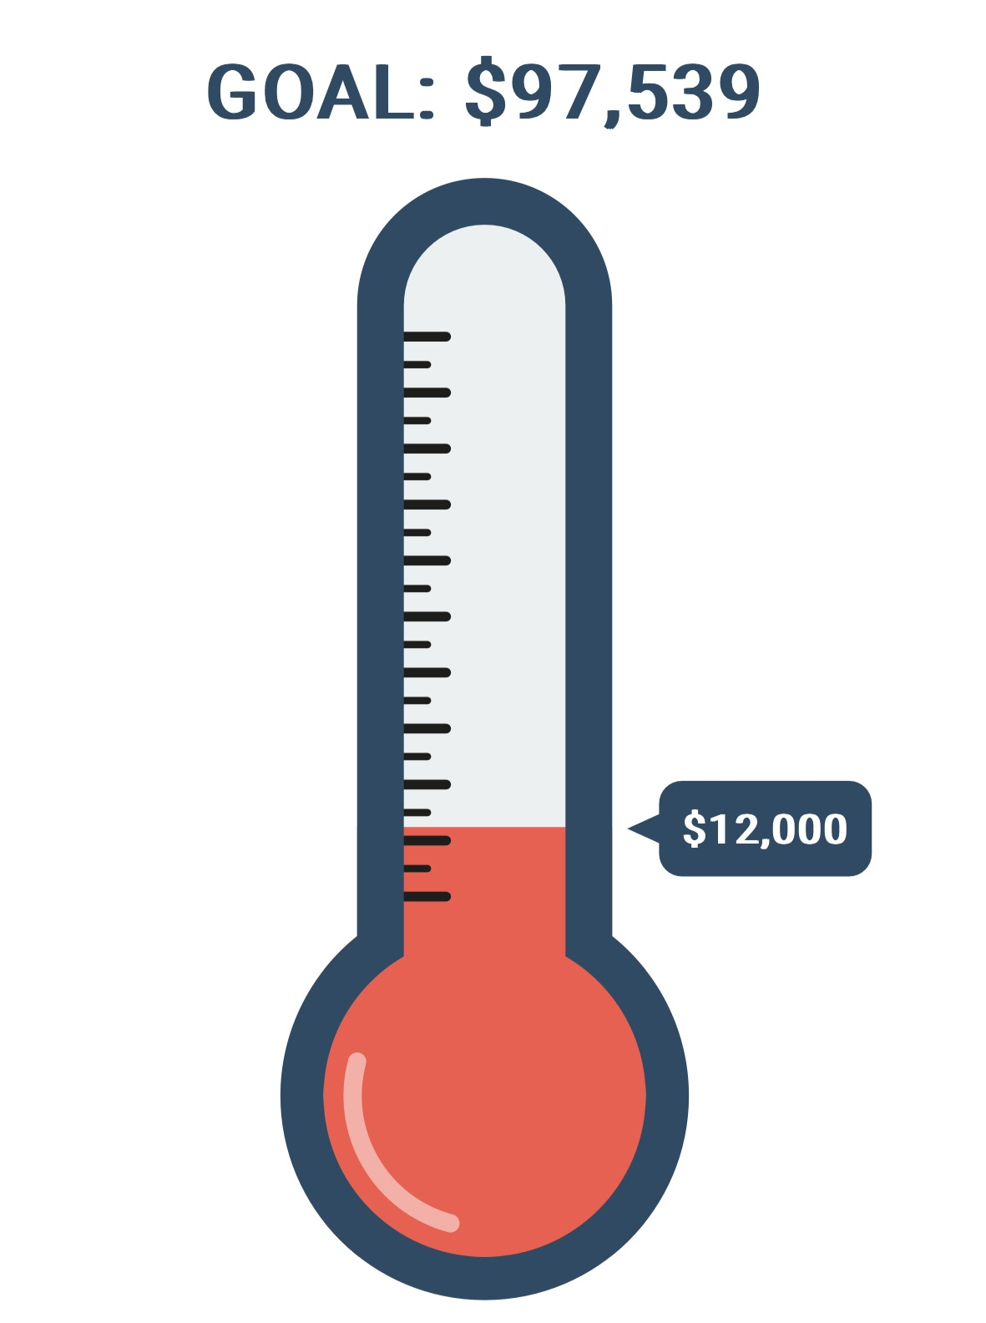  - 5 giving $20,000  - 10 giving $10,000  - 20 giving $5,000  - 50 giving $2,000  - 100 giving $1,000  Every gift, no matter the size, brings us closer to our goal! To join, simply write “Faithful 5” on your EFT or donation envelope. Track our progress each week in the Wavelength - let’s fill it together over the next 5 weeks!  Thank you for your faithful generosity! |  | UCEF needs your support  Please consider contributing to the finances of the United Christian Education Foundation (UCEF). We are losing financially each month by just over $900. If we want this high school ministry to continue as has been the ongoing vision, then we need more people to give financially to UCEF. Pray that God will provide the finances needed to keep this ministry going. There is an upcoming Movie Fundraising Event for UCEF on Friday 11th April 2025. Donations can be made to UCEF Westpac BSB:032701 Acc/no: 122963  ____________________________________________________  Tip Vouchers Needed  We are getting ready to clean up our Ulladulla site post renovations and would greatly appreciate any 2025 tip vouchers that you may have stuck to your fridge that you are not using. Please drop them into the bookshop/ office or bring them to church with you for the wardens to collect.  ___________________________________________________________________  Daily Readings Update  We're retiring our printed daily readings—thank you to those who’ve faithfully prepared them over the years!  Instead, we encourage everyone to check out physical resources available at our bookshop, or excellent digital options:  —Read Scripture App – full-Bible journey with short video explainers from The Bible Project.  —YouVersion Bible App – free, flexible reading plans for all seasons.  —Anglican Daily Office – lectionary-based prayers and readings (available via epray or online).  If you’d like help choosing a plan that fits your rhythm, speak to Steve or Aiden.

